TABLES

FRAMES

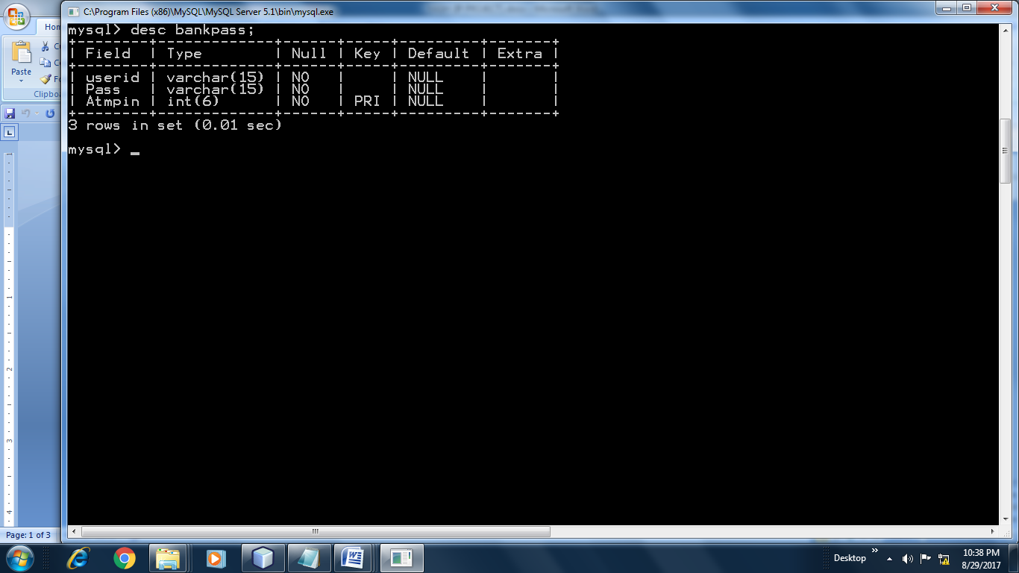

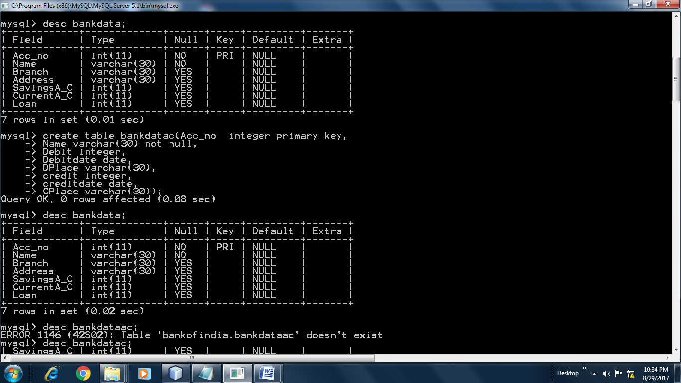

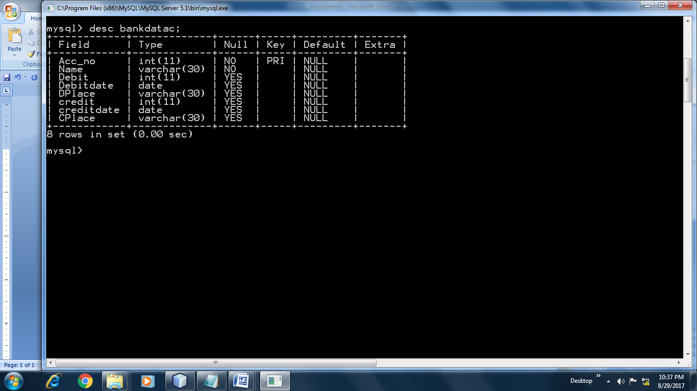

**FOR Table-1(bankpass)**

Create table bankpass(userid varchar(15) NOT NULL,

Pass varchar(15) NOT NULL,

Atmpin integer(6) Primary Key);

**FOR Table-2(bankdata)**

create table bankdata(Acc_no integer primary key,

Name varchar(30) not null,

Branch varchar(30),

Address varchar(30),

SavingsA_C integer,

CurrentA_C integer,

Loan integer );

**FOR Table-3(bankdataac)**

create table bankdatac(Acc_no integer primary key,

Name varchar(30) not null,

Debit integer,

Debitdate date,

DPlace varchar(30),

credit integer,

creditdate date,

CPlace varchar(30));